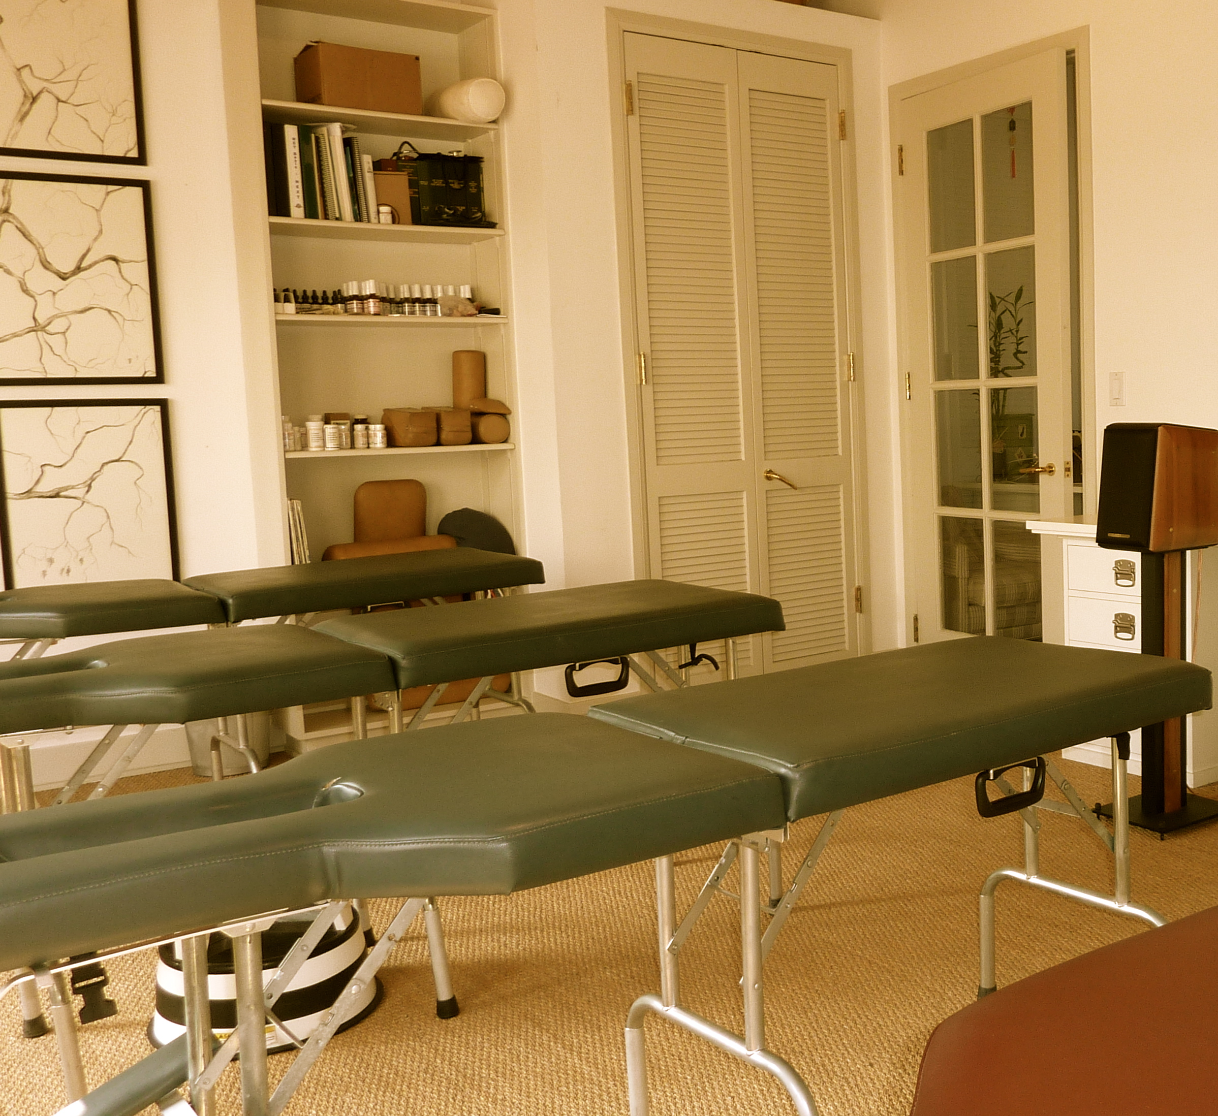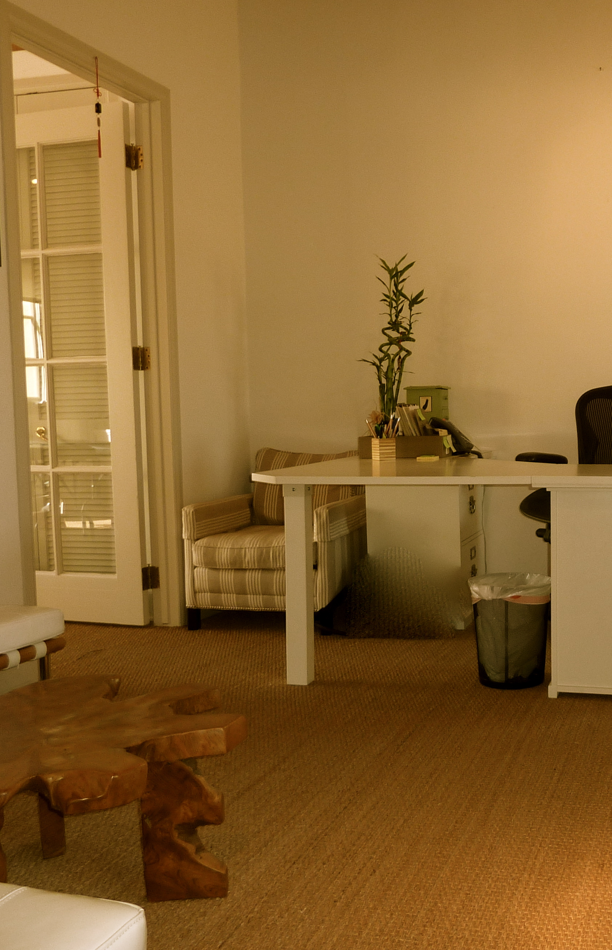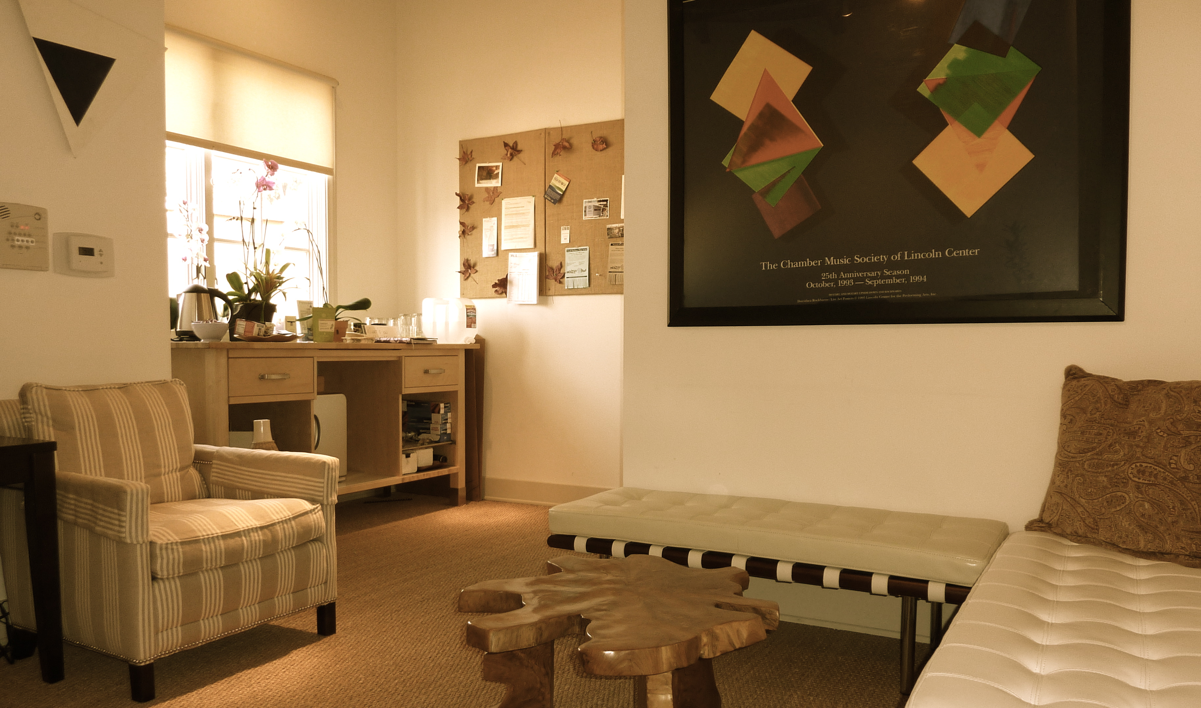
Dr. Michael S. Kooby, D.C.
323-521-3265
"Dr. Michael Kooby is a highly outstanding practitioner and a deeply compassionate person. Every entrainment with him is an adventure in life
and contributes substantially not only to the wellness of my physical, mental, and emotional body, but also to the spiritual explorations of my soul. We are all exceedingly fortunate that he has established his practice in Southern California." -- Ralph Kilmann, Ph.D.

The body is a self-corrective mechanism. Any pain or dysfunction in the body is how the body expresses distortion in consciousness. Those patterns of distortion show up within the structure, emotion and body chemistry as well as the energetic fields.
Once the body finds these underlying distortions that the symptom is expressing, the person can heal.
The distortions created in the body over a lifetime also create associated paradigms affecting behavior, relationship dynamics, thought patterns, and reactions.
Once clear and open communication is created between the structure, emotion and body chemistry and how they function, a new path is cleared for these aspects that have worked against you to fuel your growth.

1101 Montana Avenue * Suite C
Santa Monica, CA 90403
www.michaelkooby.com
32

How Does I Be Work?

What people are saying about I Be..

  - Where Eastern and Western Medicine Meet…

Integrated Bio-energetics
Michael Kooby is a great body whisperer. He connected me to mind and heart, and to a flow in my body I was not attuned to before. What MK does is not readily definable and yet what he does in body work has an embraceable and yet mysterious definition to it that speaks directly to the intelligence of your body-mind. The work is effortless at the same time that it is demanding; I very much have appreciated each call to focus. His realignment of my “placement here on the earth” has challenged me to commune with myself in a different way, and peacefully so. I am now awakened to possibilities. To experience energetically the confluence of his “work” with you and in you is like being given a key to open a door—your own!—and to confidently trust the direction of your dreams and the life you’ve imagined. I now value my body-mind. I now enjoy listening to the wisdom of my body. Thanks, Michael. The encounter has been a true gift.
.
Integrative Bio-energetics, or I Be was created and developed by Dr. Michael S. Kooby, D.C., a chiropractor with 20 years experience.
“When I first began practicing chiropractic, I would wonder after a few visits why a person had the same patterns time after time. As a part of the chiropractic techniques I utilized it was expected. I began to wonder why a person had one particular pattern as opposed to another. I wondered what things they were doing in their lives to either create or reinforce those patterns. I wondered what kind of mental and emotional stresses created or locked in those patterns.
But mostly, I wondered what it was that they could do for themselves to correct their own patterns.
This led me into the more gentle, non-force chiropractic methods. I discovered here that a gentle stimulus would produce a great response. I also saw that people began to notice changes in their emotions and in how they were able to mentally manage stress and their lives. But there was still no individual empowerment.
I began studying other energy works, paying attention to other systems that were based on client engagement. I observed what different people in my practice were doing as parts of their daily lives, and I observed the ones who did particularly better than the others. I began to pool resources together. I even travelled to India to study further. And it all came together.
Integrative Bio-energetics (I Be) combines gentle bodywork, emotional work, detoxification, yoga, breath, movement, and chakra balancing.
What differentiates I Be is its ability to draw on precisely what a person needs in each exact moment and in how it encourages client participation to the point of continually empowering them to a greater level with each successive visit.”

What is Integrative Bio-energetics (I Be) and why is it necessary?

